

**Question/Answer Booklet**

**Name:**

**PHYSICAL EDUCATION STUDIES**

**Yr 11 ATAR**

**Functional Anatomy Test**

**Time allowed for this paper**

Working time for paper: 55 minutes

**Material required/recommended for this paper**

***To be provided by the supervisor***

This Question/Answer Booklet

|  |  |  |  |
| --- | --- | --- | --- |
| **Contents:**  Functional Anatomy | Multiple choice  Short answers  Extended question | 15 marks  45 marks  10 marks  **Total marks** | **/70** |

**Multiple Choice (15 marks)**

1. What relationship do antagonistic pairs of muscles have?

(a) They have nothing to do with each other

(b) One is always the origin or the insertion for the other

(c) When one is contracting the other is relaxing and vis versa

(d) If one is contracting isotonically the other is relaxing isometrically

2. Which of the following muscle groups are antagonistic pairs?

(a) Hamstrings, soleus.

(b) Pectorals, latissimus dorsi.

(c) Trapezius, biceps.

(d) Tibialis posterior, soleus.

3. The accurate description of the position of the forearms in the anatomical or reference position would be:

(a) Pronated

(b) Rotated

(c) Supinated

(d) Adducted

4. Extension of the knee joint involves:

(a) The hamstrings and gastrocnemius coming closer together.

(b) The hamstrings and gastrocnemius moving further apart.

(c) The tibialis anterior and gastrocnemius coming closer together.

(d) The tibialis anterior and gastrocnemius moving further apart.

5. Identify the joint movement performed by a swimmer’s shoulders during a backstroke race:

(a) Adduction.

(b) Flexion.

(c) Extension.

(d) Circumduction.

6. White blood cells are responsible for

(a) fighting infection

(b) transporting nutrients

(c) blood clotting

(d) transporting nutrients

7. Which of the following is not a characteristic of capillaries?

(a) aid in diffusion during gas exchange.

(b) have thick walls.

(c) are microscopic.

(d) have strong elastic walls.

8. Pulmonary circulation involves

(a) circulation of the blood between the heart and body tissue.

(b) blood that is high in concentration of oxygen and low in concentration of carbon dioxide.

(c) blood that is low in concentration of oxygen and high in concentration of carbon dioxide.

(d) circulation of blood between the heart and the lungs.

9. Gaseous exchange occurs between the capillaries and which respiratory system component?

(a) diaphragm

(b) alveoli

(c) pharynx

(d) bronchiole

10. What is another name for the voice box?

(a) pharynx

(b) vocals

(c) larynx

(d) Adam’s apple

11. Blood from the left side of the heart is known as:

(a) Atrial

(b) Venous

(c) Deoxygenated

(d) Oxygenated

12. In which of the following does blood have the lowest concentration of oxygen?

(a) Arteries

(b) Pulmonary vein

(c) Pulmonary artery

(d) Inferior vena cava

13. The pathway from the environment to the lungs is as follows:

(a) pharynx - larynx - trachea - bronchi - bronchioles - alveoli.

(b) trachea - pharynx – larynx - bronchioles – bronchi - alveoli

(c) alveoli - bronchioles - bronchi - trachea - pharynx - larynx.

(d) larynx - pharynx - trachea - bronchi - bronchioles - alveoli

14. The major muscles used in respiration are the:

(a) diaphragm and abdominals.

(b) diaphragm and intercostals.

(c) abdominals and intercostals.

(d) trapezius and peroneus longus.

15. As you breathe in the diaphragm;

(a) contracts and flattens

(b) relaxes and flattens

(c) contracts and becomes dome shaped

(d) relaxes and becomes dome shaped

**Short Answer (45 marks)**

**Question 1 (5 marks)**

List all **5** (***five***) functions of the skeletal system.

**Question 2 (7 marks)**

**G**

**F**

**E**

**D**

**C**

**B**

**A**

Identify the bones A through to G on the diagram above.

|  |  |  |
| --- | --- | --- |
| **A.** | **B. Scapula** | **C.** |
| **D.** | **E.** | **F.** |
|  | **G.** |  |

**Question 3 (6 marks)**

Identify the **muscles** A through to F on the diagram below.

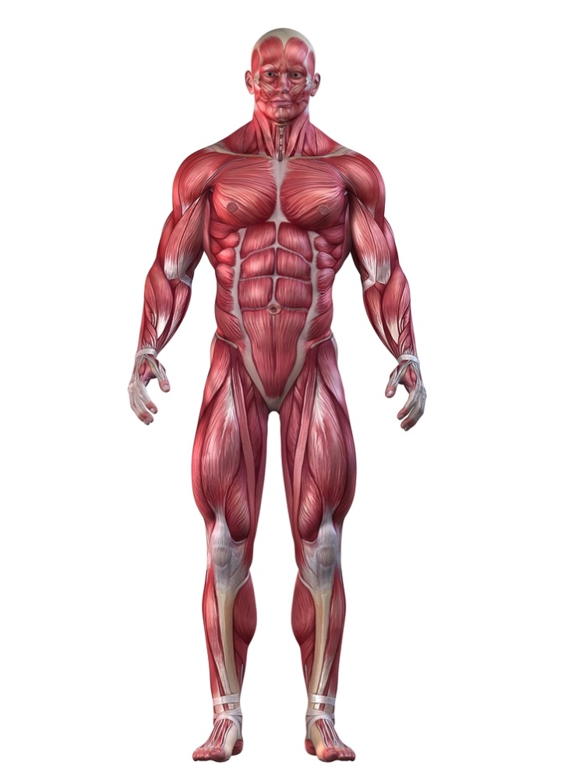

**A**

**B**

**C**

**D**

**E**

**F**

|  |  |  |
| --- | --- | --- |
| **A.** | **B.** | **C.** |
| **D.** | **E.** | **F.** |

**Question 4 (6 marks)**

The diagram below shows the muscles involved in a bicep curl. ***On the diagram:***

1. ***Name*** both muscles shown
2. Identify the ***agonist*** and ***antagonist***
3. On the Agonist muscle, identify the ***origin*** and ***insertion*** ***point***

**Question 5 (4 marks)**

Explain how an antagonistic pair work together whilst performing a squat.

**Question 6 (4 marks)**

Complete the table below, naming and defining the characteristics of skeletal muscle.

|  |  |
| --- | --- |
| **Characteristic** | **Definition** |
|  | *The ability of a muscle to contract in response to a signal or nerve impulse sent from the Central Nervous System* |
|  |  |
|  | *The ability of a muscle to stretch beyond its regular resting length* |
|  |  |

**Question 7 (4 marks)**

The body consists of three types of blood vessels: arteries, veins and capillaries. ***Compare*** and ***contrast*** the structure and function of veins and arteries.

**Question 8 (5 marks)**

Label the diagram of the heart below.

**Question 9 (4 marks)**

Describe the mechanics of **inspiration** and **expiration**.

**Extended Answer (10 marks)**

**Question 1 (10 marks)**

The image below shows gas exchange taking place at the alveoli in the lungs. For this to occur there must be a concentration gradient; a difference in concentration across a membrane. Discuss how gas exchange in the lungs occurs and how the structure of the lungs allows this to take place efficiently.

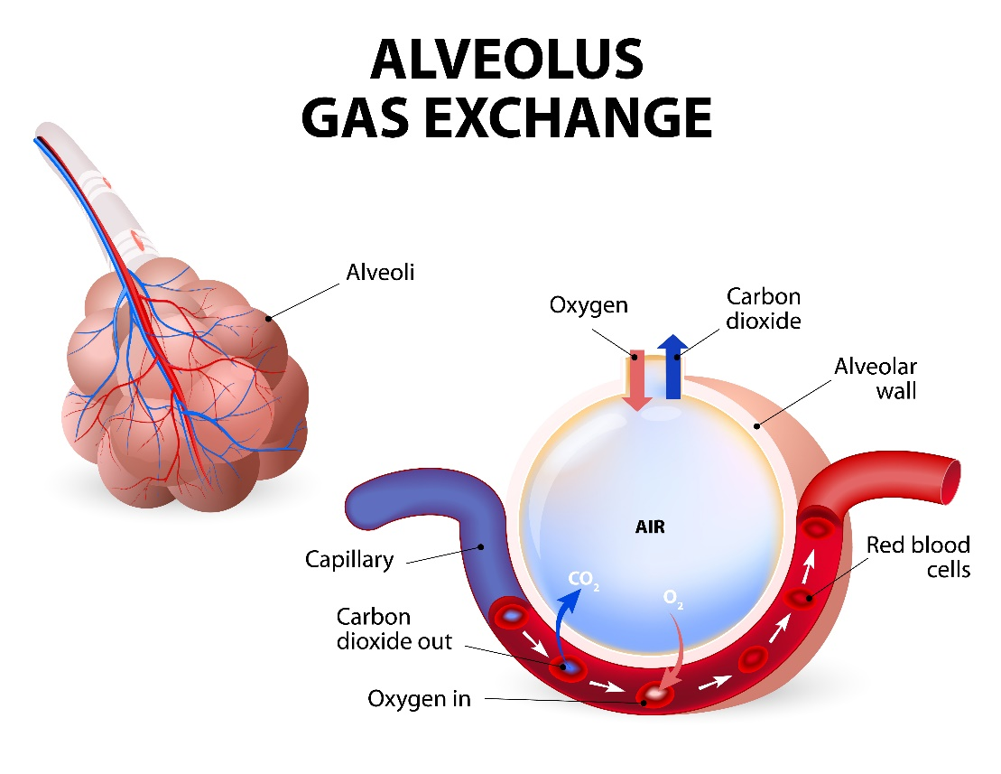

**End of TEST**

**MARKING KEY**

**Multiple Choice (10 marks)**

|  |  |  |  |  |  |  |  |  |  |  |  |  |  |  |
| --- | --- | --- | --- | --- | --- | --- | --- | --- | --- | --- | --- | --- | --- | --- |
| 1 | 2 | 3 | 4 | 5 | 6 | 7 | 8 | 9 | 10 | 11 | 12 | 13 | 14 | 15 |
| C | B | C | B | D | A | B | D | B | C | D | D | A | B | A |

**Short Answer (45 marks)**

**Question 11 (4 marks)**

List 4 functions of the skeletal system.

|  |  |
| --- | --- |
| Marks | Possible answers |
| 1 mark each | Support Protection Storage of minerals  Movement Production of red blood cells Endocrine regulation |

**Question 12 (7 marks)**

Identify the bones A through to G on the diagram above.

|  |  |  |
| --- | --- | --- |
| **A. Clavicle** | **B. Scapula** | **C. Humerus** |
| **D. Radius** | **E. Ulna** | **F. Carpels** |
|  | **G. Metacarpals** |  |

**Question 13 (6 marks)**

Identify the **muscles** A through to F on the diagram below.



**A**

**B**

**C**

**D**

**E**

**F**

|  |  |  |
| --- | --- | --- |
| **A. Trapezius** | **B. Pectorals** | **C. Bicep** |
| **D. Abdominals** | **E. Quadriceps** | **F. Gastrocnemius** |

**Question 14 (6 marks)**

The diagram below shows the muscles involved in a bicep curl. On the diagram:

1. Name both muscles shown
2. Identify the agonist and antagonist
3. On the Agonist muscle, identify the origin and insertion point

**Origin**

**Bicep – Agonist**

**Tricep – Antagonist**

**Insertion**

**Question 16 (4 marks)**

Explain how an antagonistic pair work together whilst performing a squat.

The antagonistic pair of muscles involved in the squat are the quadriceps and hamstrings.

During the downward phase, the hamstrings contract (agonist) and the quadriceps relax (antagonist). This action creates flexion at the knee.

As the quadriceps contract (agonist) and the hamstrings relax (antagonist) the legs straighten and extension occurs at the knee.

**Question 15 (4 marks)**

Complete the table below, naming and defining the characteristics of skeletal muscle.

|  |  |
| --- | --- |
| **Characteristic**  **(1/2 mark)** | **Definition**  **(1 mark)** |
| *Excitability* | *The ability of a muscle to contract in response to a signal or nerve impulse sent from the Central Nervous System* |
| *Contractibility* | *The ability of a muscle to shorten or reduce in length (or similar definition)* |
| *Extendibility* | *The ability of a muscle to stretch beyond its regular resting length* |
| *Elasticity* | *The ability of a muscle to return back to its original resting length after being stretched (or similar definition)* |

**Question 16 (4 marks)**

The body consists of three types of blood vessels: arteries, veins and capillaries. ***Compare*** and ***contrast*** the structure and function of veins and arteries.

|  |  |
| --- | --- |
| Marks | Possible answers |
| 1 mark each characteristic | Characteristic 1  Arteries have thick elastic walls. Veins have thin, less elastic walls.  Characteristic 2  Arteries carry blood away from the heart. Veins carry blood to the heart.  Characteristic 3  Blood flow in arteries is created by heart beat/pulse. Blood flow in veins is created by muscular contraction.  Characteristic 4  Arteries typically carry blood rich in oxygen. Veins typically carry blood low in oxygen.  Characteristic 5  Arteries do not have valves. Veins contain valves.  NOTE: Answer must mention the characteristic from both arteries AND veins i.e. need to compare and contrast. |

**Question 17 (5 marks)**

Label the diagram of the heart below.

|  |  |
| --- | --- |
| Marks | answers |
| ½ mark for each of the following: | Aorta  Pericardium  Left Atrium  Right Atrium  Superior Vena Cava  Inferior Vena Cava  Left Ventricle  Right Ventricle  Pulmonary Artery  Pulmonary Vein |

**Question 18 (4 marks)**

Describe the mechanics of **inspiration** and **expiration**.

|  |  |
| --- | --- |
| Marks | answers |
| Any for  1 mark (must have both inspiration and expiration) | Inspiration:  Diaphragm contracts and pulls down  Diaphragm is flattened  Intercoastal muscles contract to pull the ribcage outwards  Air pressure is low  Lung capacity is high  Expiration:  Diaphragm relaxes and draws upward  Diaphragm is dome shaped  Intercoastal muscles relax causing the ribcage to draw inwards  Air pressure is high  Lung capacity is low |

**Extended Answer (10 marks)**

**Question 16 (10 marks)**

The image below shows gas exchange taking place at the alveoli in the lungs. For this to occur there must be a concentration gradient; a difference in concentration across a membrane. Discuss how gas exchange in the lungs occurs and how the structure of the lungs allows this to take place efficiently.

|  |  |
| --- | --- |
| Description | Marks |
| During inhalation oxygen enters the alveoli | 1 mark |
| Venous blood/deoxygenated blood travels through the capillaries that run past the alveoli | 1 mark |
| The blood flowing past the alveoli is low in oxygen concentration/pressure | 1 mark |
| Oxygen concentration/pressure inside the alveoli is higher | 1 mark |
| Gasses move from area of high pressure to area of low pressure | 1 mark |
| Oxygen diffuses from the alveoli into the blood | 1 mark |
| The blood flowing past the alveoli is higher in carbon dioxide concentration/pressure than inside the alveoli | 1 mark |
| Carbon dioxide diffuses from the blood into the alveoli | 1 mark |
| Diffusion can occur due to the walls of the capillaries and alveoli being only one cell thick | 1 mark |
| Alveoli are very tiny and provide a large surface area for efficient gas exchange | 1 mark |